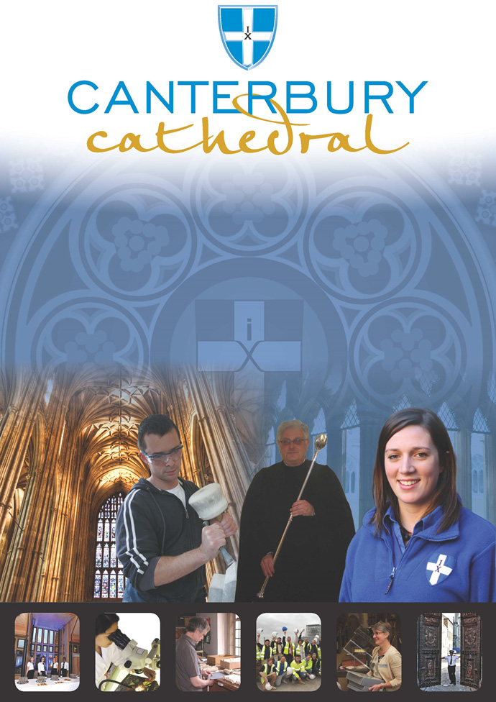

PROFILE OF CANTERBURY CATHEDRAL
St Augustine, the first Archbishop of Canterbury, arrived on the coast of Kent as a missionary to England in 597 AD. He came from Rome, sent by Pope Gregory the Great. It is said that Gregory had been struck by the beauty of Angle slaves he saw for sale in the city market and dispatched Augustine and some monks to convert them to Christianity. Augustine was given a church at Canterbury (St Martin’s, after St Martin of Tours, still standing today) by the local King, Ethelbert whose Queen, Bertha, a French Princess, was already a Christian. This building had been a place of worship during the Roman occupation of Britain and is the oldest church in England still in use. Augustine had been consecrated a bishop in France and was later made an archbishop by the Pope. He established his seat within the Roman city walls (the word cathedral is derived from the Latin word for a chair ‘cathedra’, which is itself taken from the Greek ‘kathedra’ meaning seat.) and built the first cathedral there, becoming the first Archbishop of Canterbury. Since that time, there has been a community around the Cathedral offering daily prayer to God; this community is arguably the oldest organisation in the English speaking world. The present Archbishop, The Most Revd Justin Welby, is 105th in the line of succession from Augustine.
Augustine’s original building lies beneath the floor of the nave– it was extensively rebuilt and enlarged by the Saxons, and the Cathedral was rebuilt completely by the Normans in 1070 following a major fire. There have been many additions to the building over the last nine hundred years, but parts of the quire and some of the windows and their stained glass date from the 12th century.
By 1077, Archbishop Lanfranc had rebuilt it as a Norman church, described as “nearly perfect”. A staircase and parts of the North Wall – in the area of the North West transept also called the Martyrdom – remain from that building.
During the Second World War, the Precincts were heavily damaged by enemy action and the Cathedral’s Library was destroyed. Thankfully, the Cathedral itself was not seriously harmed, due to the bravery of the team of fire watchers, who patrolled the roofs and dealt with the incendiary bombs dropped by enemy bombers.
Today, the Cathedral stands as a place where prayer to God has been offered daily for over 1,400 years; nearly 2,000 services are held each year, as well as countless private prayers from individuals. The Cathedral offers a warm welcome to all visitors – its aim is to show people Jesus, which we do through the splendour of the building as well as the beauty of the worship.

THE WORK OF THE CATHEDRAL
The work of the Cathedral is carried out by over 300 paid staff, supported by some 500 volunteers. The ‘corporate body’ responsible for the management of the Cathedral is the Chapter of Canterbury who are advised by the Cathedral Council and the College of Canons.

The Chapter of Canterbury (Chapter)
The Chapter are responsible for all aspects of the day-to-day management of the Cathedral. Chapter comprises the Dean, the Residentiary Canons, the Receiver General and four additional persons appointed by the Archbishop.

The Cathedral Council
The Council represents the Cathedral community as well as the wider local and regional community. It has 20 members, drawn from a wide variety of organisations. Its duty is to further and support the work of the Cathedral Church in spiritual, pastoral, evangelistic, social and ecumenical areas.

The College of Canons
The College of Canons is composed of 30 Honorary, Lay and Provincial Canons, appointed by the Archbishop and it supports the life of the Cathedral in many different ways.

The Cathedral Trust
The Cathedral Trust is a separate charity that is solely for the benefit of the Cathedral. Since 1974, it has assisted with the restoration, maintenance and improvement of the fabric and contents of Canterbury Cathedral and the provision, promotion and encouragement of music
The Cathedral is well-known all over the world and we welcome more than 1 million visitors and worshippers every year. The Cathedral is more than just a beautiful old building and heritage site; it is a working, living church which maintains a tradition of welcome and worship that has been practiced here for over 1400 years.

Friends
The Friends of Canterbury Cathedral was founded in 1927 by the distinguished scholar and poet Dean George Allen Kennedy Bell. The Organisation was the first of its kind in the world.
The Friends are the Cathedral’s fan club. Admirers of the building, its history and its community, Friends are a part of the Cathedral and work together to preserve it forever, contributing financially - and directly – to many individual and vital projects.

The Cathedral Shop
The Canterbury Cathedral Shop is a large gift shop in the heart of the city of Canterbury. It has an impressive range of high quality gifts, mostly British, and their own exclusive award winning designs.
The Shops wide range of merchandise includes replica historical artefacts, books and CD’s of the world-famous Canterbury Cathedral choir.

THE CANTERBURY JOURNEY
This role is supported by The Canterbury Journey, which aims to engage new, hard-to-reach and diverse audiences with heritage and the collections through the Activity Plan. The Activity Plan volunteer programme enables training and new skills development in interpretation, collections care, informal learning, community engagement and outreach to help increase knowledge transfer and employability within the heritage sector.
The Memories Project is set out in the Activity Plan and comprises four capsule projects which, over the next 3 years, will build into a unique community archive and a publication for Canterbury Cathedral.
The aim of the Memories Project is to gather memories which provide a rich vein of colourful, entertaining and very accessible content for use in new Cathedral interpretation, exhibitions and events. These interviews will be added to the Cathedral’s archive collection to provide access to them for current and future generations of researchers.

ROLE PROFILE
The Oral History Transcriber will be responsible to the Community Engagement Manager.

Purpose/ summary of role

The Oral History Transcriber and Oral History Interviewer roles are key to unlocking Canterbury Cathedral’s living community archive. These roles will collate people’s experiences and memories of the Cathedral and city through wide ranging interviews. The interviews will focus on the way the Cathedral has influenced the lives of those interviewed.
Oral History Interviewers will receive training delivered by the University of Kent in how to conduct interviews that allow a person to tell their own story in their own words. Interviewers will also be given basic training in how to use the recording equipment.
Oral History Transcribers will use their transcription skills to write up the interviews by listening to those that have been recorded by others.
Description of tasks and activities

- Listening to the Oral History Interviews in full in order to transcribe accurately.
- Working from home and/ or the Cathedral with computer and listening equipment.

Time Commitment

- One half day of training. Date and time TBC.
- The time it takes to transcribe each interview will vary. It’s unlikely that a recorded interview will be less than an hour in duration. Transcribing will take several hours per hour of recorded interview.
- We would like transcribers to commit to transcribing at least 3 interviews over the course of a year.

Skills

Oral History values people and their stories. In transcribing these interviews, you will be recording the exact words of an interviewee as well as noting how they say it. That way these transcriptions will have the added significance of being a record of how stories, memories and anecdotes are told in this living archive.
- A keen interest in people and their stories.
- Experienced with transcription and/ or dictation.
- Ability to follow the training advice and use the recording equipment correctly.
- Computer literate.
- Good communication skills.
- Outgoing, friendly and proactive character.
- Be comfortable volunteering by yourself.
- Being able to use your own initiative but be able to ask for help when you need it.

Training and Support

- Training in how use the audio equipment as well as in transcription.
- Induction to the Cathedral.
- Full training on all aspects of the role.
- Regular updates on organisational activities.
- Support, advice and guidance from the Community Engagement Manager and The Canterbury Journey Team.

Benefits to volunteer

- The opportunity to develop new and existing skills and gain experience volunteering at a world heritage site.
- An introduction to heritage interpretation.
- A chance to meet new people and share your passion and skills with staff and other volunteers.
- A chance to be part of an exciting and interesting project.
- The satisfaction of knowing you are making an important contribution to the work of the Cathedral and supporting the Cathedral’s collections.

TERMS AND CONDITIONS
Duration

The time it takes to transcribe each interview will vary. It’s unlikely that a recorded interview will be less than an hour in duration. Transcribing will take several hours per hour of recorded interview.

Trial Period
All new posts are subject to a trial period.

Training
Training needs are assessed continuously and appropriate on the job training is provided.

Parking

The Chapter of Canterbury is not able to offer volunteers parking on site.

Volunteer benefits

We are able to offer a range of volunteer benefits including discounts in local shops, restaurants and sports centres.

EQUALITY STATEMENT
The Chapter of Canterbury recognises that discrimination and victimisation is unacceptable and that it is in the interests of the organisation and its employees and volunteers to utilise the skills of the total workforce. It is the aim of the organisation to ensure that no employee, volunteer or job applicant receives less favourable facilities or treatment (either directly or indirectly) in recruitment or employment on grounds of age, disability, gender / gender reassignment, marriage / civil partnership, pregnancy / maternity, race, religion or belief, sex, or sexual orientation.
October 2019

This role profile is provided to assist the volunteer to know their principal duties. It may be amended from time to time in consultation with you.

HOW TO APPLY

- Register and submit an application Form via CV Minder
(http://canterbury-cathedral.org/get-involved/employment/vacancies)
- Shortlisted applicants will be invited to attend an informal interview
- Offers will be subject to the receipt of 2 satisfactory references
- All new volunteers will carry out an Induction process
- Appropriate training will be given
- Appointees will be subject to a trial period

Contact Information if you would like to know more before applying:

Liam O’Driscoll, Community Engagement Manager

Email: Journey@canterbury-cathedral.org
Telephone: 01227 862796

Applications should be submitted using the Cathedral volunteer application form, and all sections must be completed. If you wish you may attach a copy of your CV to support your application.

Application forms can be found on our web pages at:

www.canterbury-cathedral.org/get-involved/employment/vacancies

The closing date for this post is:

Sunday 1st December 2019

Interviews will take place:

On a rolling basis.

Training is expected to commence:

Soon after appointment to the role.

